**CST-391 Design Report Template**

|  |  |  |
| --- | --- | --- |
| **Milestone:** | Milestone 2: Refined Project Proposal | |
| **Date:** | 12/3/2023 | |
| **Revision:** | 1.2 | |
| **Team:** | 1. Noah Funderburgh | |
|  | |
| **Weekly Team Status Summary:** | |  |  |  |  | | --- | --- | --- | --- | | **Required User Stories:** [Tasklist .xlsx](https://mygcuedu6961-my.sharepoint.com/:x:/g/personal/nfunderbur_my_gcu_edu/EXiC_QwAhm9NkJF6HPUU4jEB-7tZ6B-nLGaBTP17g0GMfA?e=eTC8Nd) | **Team**  **Member** | **Hours**  **Worked** | **Hours Remaining** | | *As a user, I want to be able to update prayers so I can change them by submitting a form* | *Noah F.* | *2* | *0* | | *As a user, I want to be able to delete prayers so I can delete them by submitting a form* | *Noah F.* | *4* | *0* | | *As a user and developer, I want to be able to create prayers so I can create them by submitting a form* | *Noah F.* | *2* | *0* | | *As a user, I want to be able to list prayers so that I can see all prayers within a website* | *Noah F.* | *2* | *0* | | *As a user and developer, I want to be able to navigate the website easily through a bootstrap nav bar* | *Noah F.* | *1* | *0* | | |
| **GIT URL:** | *https://github.com/nfunderburgh/CST-391Milestone.git* | |
| **Hosting URL:** | None | |
| **Peer Review:** | *Yes* | We acknowledge that our team has reviewed this report, and we agree to the approach we are all taking. |
| **Loom URL:** | |  |

**Design Documentation**

**Design Update**

Since the last milestone, the primary achievement has been the development of an Angular website that enables direct access to API entry points from the front end. This enhancement significantly simplifies the process for the average user to view, create, update, and delete prayers within the application. A Bootstrap nav bar was also created on the main page to assist users navigating around the website. No Changes were made to the database along with the API Entry points. Those remained the same throughout this week.

**Description of Application**

The goal of the application is to create a place where users can submit their prayer requests and pray for others. Users will be able to look at a list of prayer requests as well as create, delete, and update their own prayer requests. Upon going to the website users will be required to login and or register if they don’t have an account. Once the user logs in they will then have to access the rest of the site.

**Risks**

One of the major risks that stood out to me was privacy concerns with gathering and collecting users’ personal information. One feature I added to help combat is the ability to make the prayer request anonymous if they choose so. When users she other users’ prayer requests, they will only see the user’s first name, this is another feature for anonymity. Another potential risk is people’s diverse beliefs. Prayer is commonly used in many different religions so ensuring that the application is respectful and inclusive to people different beliefs is important to avoid unintentional offense.

**API Entry Points**

* Get Prayers – Returns a list of all prayers
  + 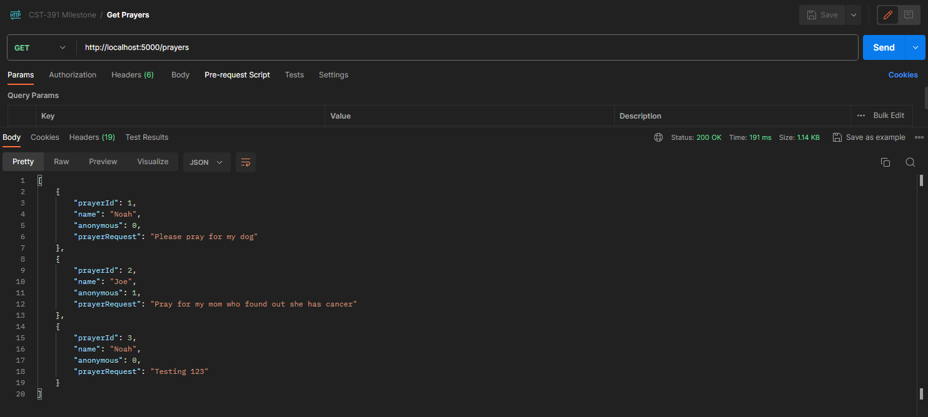<http://localhost:5000/prayers>
* Create Prayers – Create a prayer to add into the database
  + 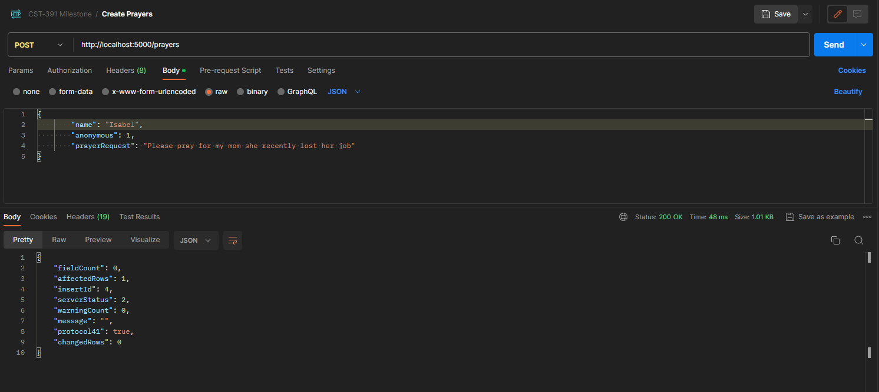<http://localhost:5000/prayers>
* Update Prayers – Update a specific prayer to within the database
  + <http://localhost:5000/prayers>

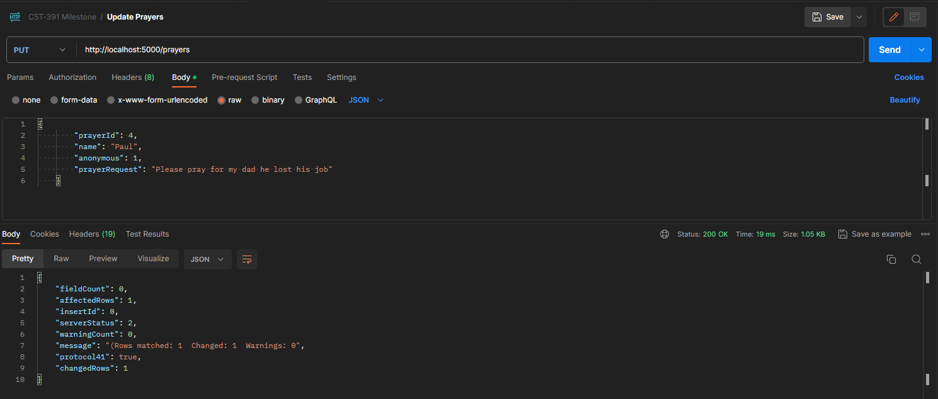

* Delete Prayers – Delete a specific prayer to within the database based off prayer Id
  + 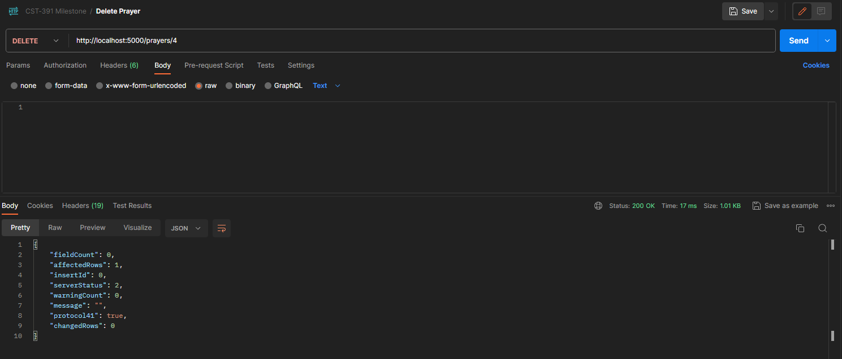http://localhost:5000/prayers/id

**Initial ER Diagram**

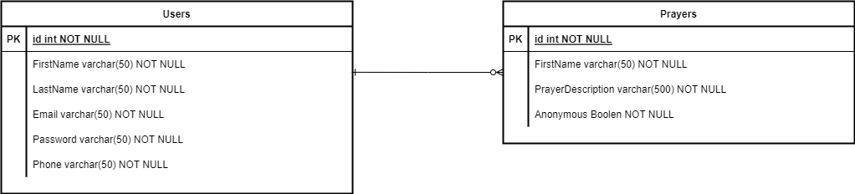

**Initial UI Sitemap**

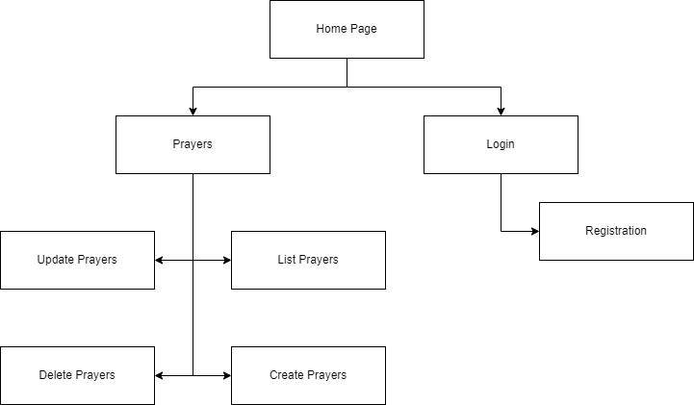

**Initial UI Wireframes**

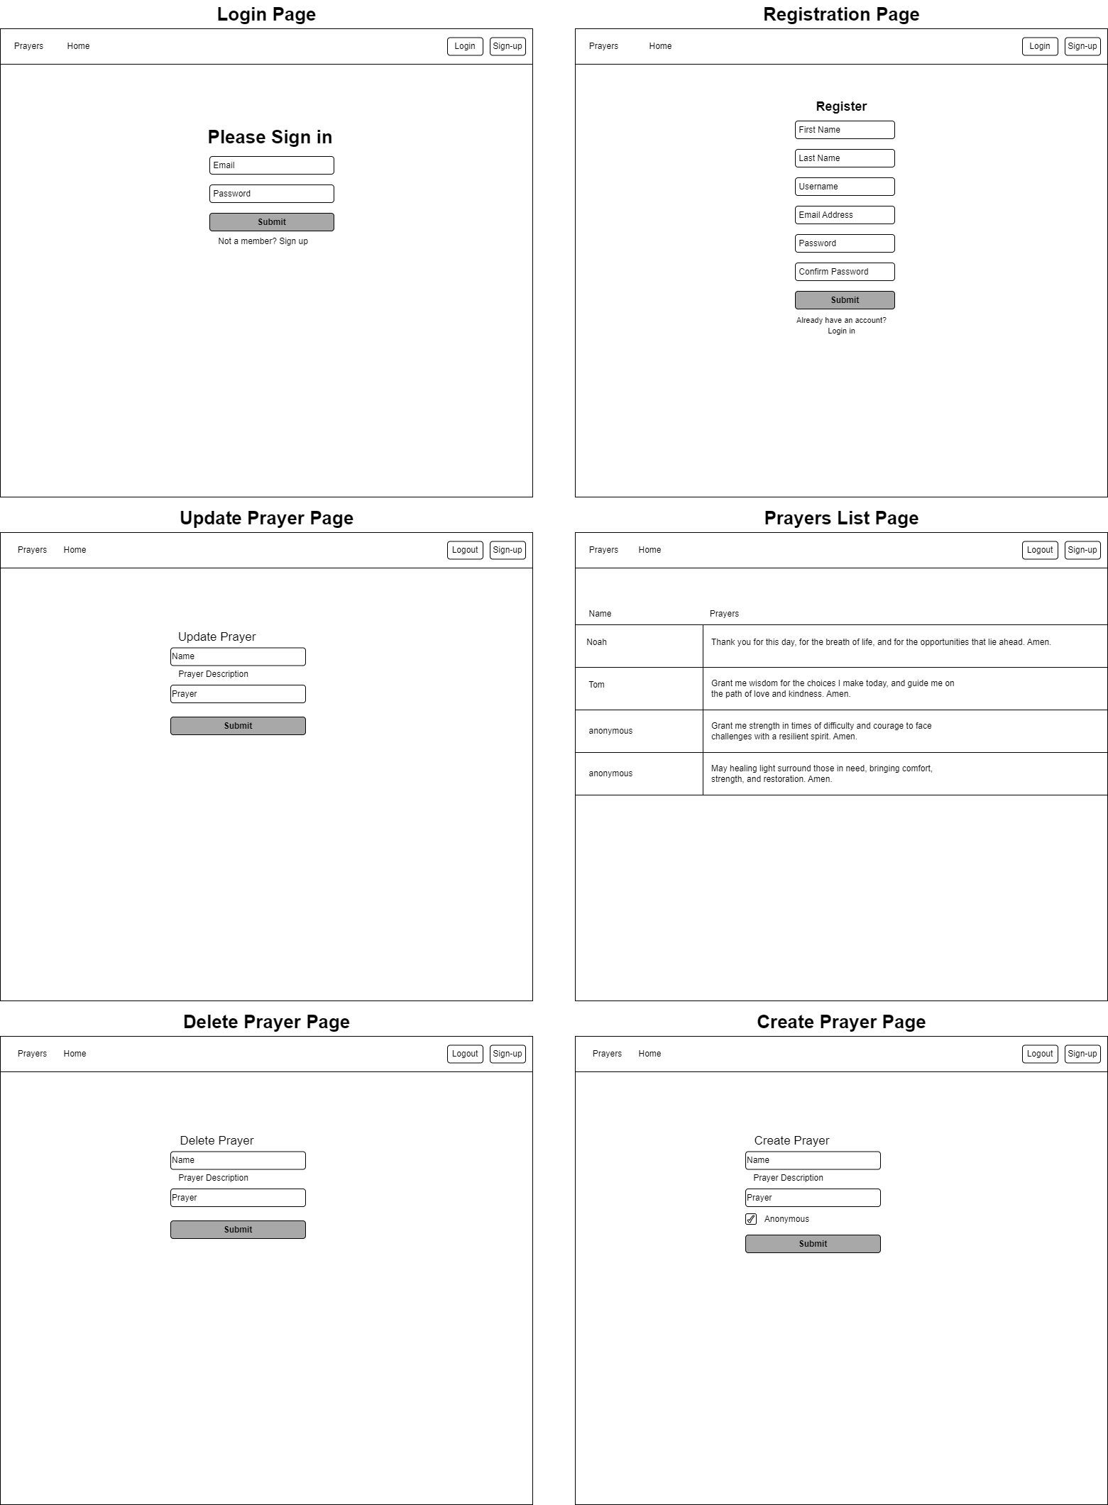

**Initial UML Classes**

